**Low Level Design Document**

**Kalasalingam Academy of Research and Education**

1. **Team Name:** Scout Regiment

**Team Members:**

|  |  |  |
| --- | --- | --- |
| **Serial Number** | **Name** | **Registration Number** |
| **1** | **Veera Akilan .V** | **9921004758** |
| **2** | **Vishwa. S** | **99210042091** |
| **3** | **Vigneshwaren .A** | **9921004772** |
| **4** | **Michael Mathura Pio .A** | **9921004450** |

**Project Overview:**

Control android phone and automate a bot to play a game using **image recognition library/api/sdk** (**TensorFlow , Keras**)

1. **Project related to: Image Recognition Library/ SDK/ API:**Leverage image recognition libraries/SDKs/APIs to build your custom image processing systems quickly and cost-effectively or to add image processing capabilities to your existing systems.

**Solution:**

Using python to run **adb** (**android debug bridge**) executable exe, to control android phone,

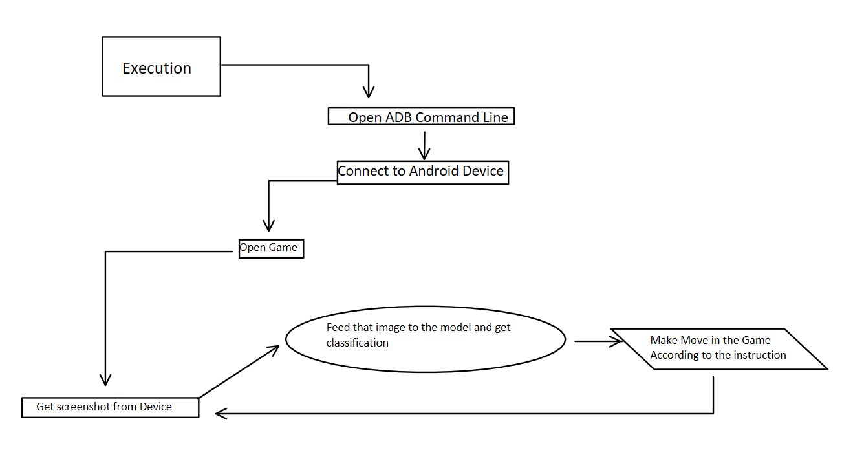In order to play games, we use **Google’s teachable machine** to train an image recognition model and while playing the game, we will take screenshots using (**adb commands**) then those screenshots are feed to the model (**using Tensorflow API**) according to the result of the model we will take decision .And also creating a kind of logger system that saves the main commands executed

**Design of the model:**

1. Architecture Model :

Steps :

* + 1. Control android device
    2. Get screenshots from connected android device
    3. Feed to model
    4. Identify the state of the game and act accordingly
    5. Log each and every process

1. Component Level Design Model:

Adb:

1. It is mostly used to debug android apps while developing application

2. It has Full control over the running shell in android

Google’s Teachable Machine:  
 1. It is the image recognition model developing website hosted by Google

2. Highly Efficient and prediction are almost accurate

TensorFlow API:

1. The trained model has been implemented using this api
2. All process from calling the model, predictions are handled here

Sqlite:

1. To create a logging database system

**Dataset Description:**

Various Images of different stages in game classified and feed to Google’s Teachable Machine

**Tools/Technologies used:**

* 1. Python
  2. Android Debug Bridge(ADB)
  3. Google’s Teachable Machine
  4. Tensorflow api
  5. Android Game
  6. Android Phone (or) Android Emmulator